WEALD OF KENT PLOUGHING MATCH ASSOCIATION

2021 TRADE STAND AND ADVERTISING PACK

To take place on 18th September 2021
at
Honey Farm, Munday Bois Road, Pluckley, Ashford, TN27 0SU
by kind permission of Mr. D Gwillim

PLEASE RETURN YOUR SIGNED PAPERWORK, A COPY OF YOUR RISK ASSESSMENT AND INSURANCE BACK TO ME VIA EMAIL OR TO THE ADDRESS BELOW, NOT THE SITE ADDRESS. IF ANY OF THE DOCUMENTS LISTED ABOVE ARE MISSING THE APPLICATION WILL NOT BE ACCEPTED
THE DEADLINE FOR APPLICATION IS 31ST MAY 2021

Little Charity
Swattenden Lane
CRANBROOK
Kent
TN17 3PS

07872 501951
lizcoppingwkpma@hotmail.com
www.wkpma.co.uk

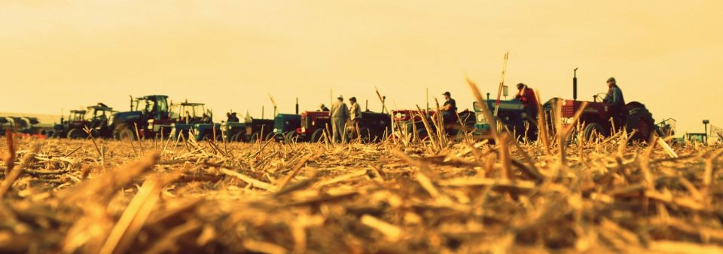

The Secretary
Little Charity
Swattenden Lane
CRANBROOK
Kent
TN17 3PS
07872 501951
Dear Trade Stand Holders/Advertisers/Exhibitor,

I am delighted to enclose details for the 2021 ploughing match which will held at Honey Farm, Munday Bois Road, Pluckley, Ashford, TN27 0SU. We very much hope that we can once again count on your support, and I would ask that you ensure that the enclosed application is returned promptly to me at the address above as well as a copy retain for your own records.

Please note that all applications must be returned by 31st May 2021 and that late applications are not guaranteed inclusion. This is especially applicable to those of you who wish to advertise within our schedule/programme of events. To keep costs to a minimum you WILL NOT be chased up! Should you have any queries then please email me - lizcoppingwkpma@hotmail.com

All setting up of stands must be completed by either 6pm the previous day, which is preferable, or if you are setting up on the Saturday the gates will be opened at 6.30am but ALL trade vehicles must be moved to the appropriate parking area NO LATER than 8.30am without exception. Appropriate vehicle badges will be provided and must be displayed. Security will be provided on the Friday and Saturday evenings, but please be aware that any loss or damage to your equipment is the responsibility of the trade stand holder. Only silent generators are permitted onsite.

The Association arranges and controls the public catering so please note that it will NOT be permitted for trade stand holders to sell food and beverage to the public under any circumstances. Hospitality is however permitted.

Should you wish to invite your customers onto your stand, please note it should be made clear that your invitation DOES NOT include entrance to the match. This has caused some embarrassment on the gate in previous years and your understanding is appreciated. Tickets are available in advance from myself at a discounted rate and are non-refundable under any circumstances. I can arrange for tickets to be printed with your company logo on; please contact me separately for a quotation regarding this no later than 30th June 2021.

Please note that no-one will be permitted onto the site without a trade stand exhibitor pass or prior payment on Match day. If your staff come onto site at any point through the day without a pass then they will have to pay with no exceptions. You can make an application to the committee to claim back their entrance fee either on the day or within 7 days of the event.

If you are intending to bring animals onto your stand, please complete the relevant form attached – no stand will be accepted without this being completed, stands who turn up on the day will be refused entry without exception.

THE WEALD OF KENT PLOUGHING MATCH ASSOCIATION RECOGNISE THAT FAILURE TO PROVIDE A RISK ASSESSMENT WHICH TAKES ACCOUNT OF COVID-19, OR COMPLETING A RISK ASSESSMENT BUT FAILING TO PUT INTO PLACE SUFFICIENT MEASURES TO MANAGE THE RISK OF COVID-19, COULD CONSTITUTE A BREACH OF HEALTH AND SAFETY LAW.

EXHIBITORS WILL BE RESPONSIBLE FOR THE RISK WITHIN THEIR TRADE STAND AND SHOULD TAKE ALL THE NECESSARY STEPS, AS OUTLINED IN THEIR RISK ASSESSMENT, TO ENSURE THE SAFETY OF THEIR OWN STAFF, BUT ALSO ALL ATTENDEES INTO THEIR STAND AREA, FOR EXAMPLE, EXHIBITORS WILL HAVE TO HAVE HAND SANITISER STATIONS ON THEIR STANDS AND KEEP MARQUEES AS OPEN AS POSSIBLE WITH GOOD VENTILATION. EXHIBITORS SHOULD DISCOURAGE ATTENDEES FROM HANDLING PRODUCTS AND HAVE DISPLAY ITEMS ONLY AND PROVIDE A SELF-SERVICE ONLY FOR ALL MARKETING MATERIAL.

FAILURE TO ADHERE TO THE HEALTH AND SAFETY POLICY ON THE DAY OF THE EVENT WILL RESULT IN THE OFFENDER BEING REMOVED FROM THE SITE.

Finally, on behalf of the Chairman and the Committee of the Association, I should like to thank you in advance of your continued support and I look forward to hearing from you at your earliest convenience.

Kind regards
Liz Copping
Secretary
Weald of Kent Ploughing Match Association
To be held on 18th September 2021 at Honey Farm, Munday Bois Road, Pluckley, Ashford, TN27 0SU

Company Name
Address

Telephone Number Mobile Number
Contact Name
Email Address

TRADE STAND SPACE
Ring-Side Space
This fee gives priority for a ring-side stand at one of the two main rings* plus
hanging space for a banner in the ring of your choice and a full-page advertisement. £250
All stands are 10 x 10 metres unless our records indicate that you have had a 20
metre frontage in the past.
*Important Note
The Committee cannot guarantee that a new applicant will have a ring-side stand and their decision is final.

*Main Trade Area 20 x 10 metre depth STAND SPACE ONLY £120
10 x 10 metre depth STAND SPACE ONLY £80

Advertising Only Full Page (Full Colour Portrait) 148mm x 210mm £120
Half Page (Full Colour Landscape) 105mm x 148mm £80

I confirm that I require the same artwork as before yes/no

Please provide camera ready artwork in colour, portrait for new full-page submissions and landscape for half page submissions. Any additional work involved in re-setting artwork shall be chargeable as appropriate

Please enclose a copy of your policy for Public Liability Insurance

Please note that acceptance of this application is conditional upon your agreement to abide by the Associations Policy for Health & Safety which is attached and completed Risk Assessment Form.

APPLICATIONS MUST BE RETURNED NO LATER THAN 31st May 2021
APPLICATIONS RETURNED WITHOUT THE APPROPRIATE PAYMENT ARE NOT
GUARANTEED ACCEPTANCE

Please make cheques payable to WKPMA
BACS payment Sort Code 60 06 18
Account 59011629
I have read and understand the Associations Rules and Regulations for Health & Safety and agree to abide by them. I understand that failure to adhere to the Associations Policy will result in exclusion or removal from the event site

Signed

Print Name Date
WKPMA RISK ASSESSMENT FORM
Please complete using BLOCK CAPITALS
Company Name:
Responsible Person:
Tele Number:
General Risk Assessment (enclose additional pages if required)
Hazard/Risk | Persons at Risk | Risk Level | Controls to minimise risk
 |  | High
 |  | Medium
 |  | Low
 |  | High
 |  | Medium
 |  | Low
 |  | High
 |  | Medium
 |  | Low
 |  | High
 |  | Medium
 |  | Low
 |  | High
 |  | Medium
 |  | Low
 |  | High
 |  | Medium
 |  | Low
 |  | High
 |  | Medium
 |  | Low
 |  | High
 |  | Medium
 |  | Low
 |  | High
 |  | Medium
 |  | Low
 |  | High
 |  | Medium
 |  | Low
 |  | High
 |  | Medium
 |  | Low
Note: Exhibitors are to wear high-viz jackets during set up and take down times.
Raised hydraulic components must be supported by mechanical means and not rely on hydraulic pressure and a safety barrier installed to prevent access below.
There should not be any protrusions into aisles or walkways e.g. drawbars etc.
STANDS WITH LIVE ANIMALS
Please complete using BLOCK CAPITALS
Company / Organisation Name:
Responsible Person: (this is the person on site on match day)
Mobile Tele Number:
Specific Risk Assessment (enclose additional pages if required)
Type of Animal  E.g. Cattle etc. | Detail your procedures for unloading, loading and holding the animals on your stand, contact with the public and biosecurity policy, plus anything else relevant to match day.
Please note that whilst WKPMA Stewards are on site, they are there for guidance to your stand only and will not assist in the movement of any animals on and off stands. Animals and members of your staff that are brought onto stands are under your supervision and the responsibility of such is entirely your own, not that of the Association

Note: Exhibitors are to wear high-viz jackets during set up and take down times.
Raised hydraulic components must be supported by mechanical means and not rely on hydraulic pressure and a safety barrier installed to prevent access below.
There should not be any protrusions into aisles or walkways eg drawbars etc

